TITLE OF THE PAPER IN UPPER CASE (Times New Roman, size 14 pt, centered Bold)

First Author¹, Second Author²(12 pt, , font Times New Roman)
¹(Authors Affiliations, email)
²(Authors Affiliations, email)

-----------------------------------------------------------------------------------------------------------
ABSTRACT: (12 pt, , font Times New Roman Bold, Italic)
It is still the industry's largest application (12 point, italic, Times New Roman font) and the reason is clear. The first reason is the technological process, etc. This post analyzes the annual... ( 12 pt. Italic, font Times New Roman)

Keywords: green economy, energy, industry, warehouse, world, Europe.
(12 pt, font Times New Roman Bold)
-----------------------------------------------------------------------------------------------------------------------

1. INTRODUCTION (12 pt, font Times New Roman Bold)
Xxxxxxxxxxxxxxxxxxxxxxxxxxxxxxxxxxxxxxxxxxxxxxxxxxxxxxxxxxxxxxxxxxxxxxxxxxxxxxxxxxxxxxxxxxxxxxxxxxxxxxxxxxxxxxxxxxxxxxxxxxxxxx[1] .12 pt, font Times New Roman.

2. OTHER TOPICS (12 pt, font Times New Roman Bold)

Xxxxxxxxxxxxxxxxxxxxxxxxxxxxxxxxxxxxxxxxxxxxxxxxxxxxxxxxxxxxxxxxxxxxxxxxxxxxxxxx[2]. 12 pt, Times New Roman.

2.1. The title of Part chapter (12 pt, font Times New Roman Bold)

Xxxxxxxxxxxxxxxxxxxxxxxxxxxxxxxxxxxxxxxxxxxxxxxxxxxxxxxxxxxxxxxxxxxxxxxxxxx[3]. Xxxxxxxxxxxxxxxxxxxxxxxxxxxxxxxxxxxxxxxxxxxxxxxxxxxxxxxxxxxxxxxxxxxxxxxxxxxxxxxxxxxxxx 12 pt, font Times New Roman

Xxxxxxxxxxxxxxxxxxxxxxxxxxxxxxxxxxxxxxxxxxxxxxxxxxxxxxxxxxxxxxxxxxxxxxxxx 12 pt, font Times New Roman.

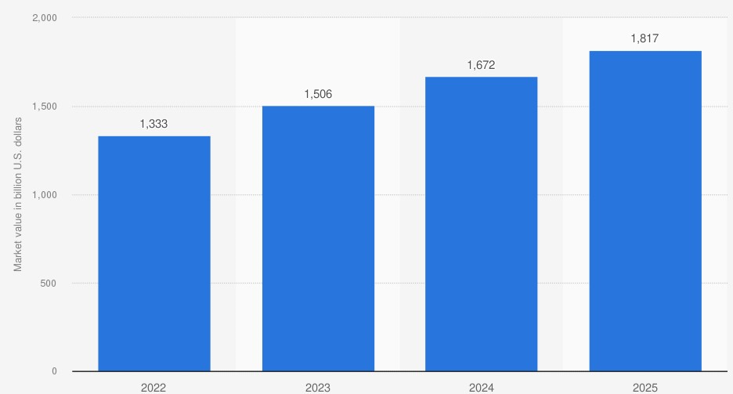

Fig.1. Xxxxxxx xxxxxxx (10 pt, font Times New Roman, centered)

Table 1. Xxxxxxxxxxxxx xxxxxxxxxxx (11 pt, font Times New Roman)

Xxxxxxxxx | Xxxxxxxxx | Xxxxxxxxxxx
to 5 | to 20 | to 100
5 – 100 | 20 – 200 | 100 - 500
- | 200 – 500 | 500 - 5000

Equationsxxxxxxxxxxxxxxxxxxxxxxxxxxxxxxxxxxxxxxxxxxxxxxxxxxxxxxxxxxxxxxxxxxxxxxxxxxxxxx ( 12 pt, font Times New Roman.)

(1)

3. CONCLUSION (12 pt, font Times New Roman Bold)

Xxxxxxxxxxxxxxxxxxxxxxxxxxxxxxxxxxxxxxxxxxxxxxxxxxxxxxxxxxxxxxxxxxxxxxxxxxxxxxxxxxxxxxxxxx (12 pt, font Times New Roman.) .

4. REFERENCES (APA style) (12 pt, font Times New Roman Bold)
- Author1 I., Author2 I., Author3 I. (1999). Title of article in the original language. Full journal title. Volume (No): first page-last page.
- Author1 I., Author2 N., Author3 N., Author4 N. (2006). Title of article in the original language. Title of book, handbook, database or journal. Volume (No): pp. Available: http://www.......com/
- Author1 N., Author2 N., Author3 N., Author4 N., Author5 N. (2003a). Title of article in the original language. Published in Full title of the proceedings, Editor's surname I. (ed.), 96–102. Place, Country: Publisher. https://doi.org/10.1007/4-431-22523-2_4

